ELEC 2110

Electric Circuit Analysis

Gabriel Emerson

Jake Bryson

October 22, 2019

Section 002

Recitation and MultiSim: AC Analysis

Introduction

In this lab, the student will learn AC steady state circuit calculations, and learn to perform AC Analysis using MultiSim circuit simulator. The student will be given a circuit, and calculate the value of V(t) and/or i(t), then simulate the circuit in MultiSim to verify the answer.

Exercise 1

Calculate i(t) and V(t) if frequency = 60Hz for circuit 1. Simulate in MultiSim and perform AC Sweep and plot magnitude and phase.

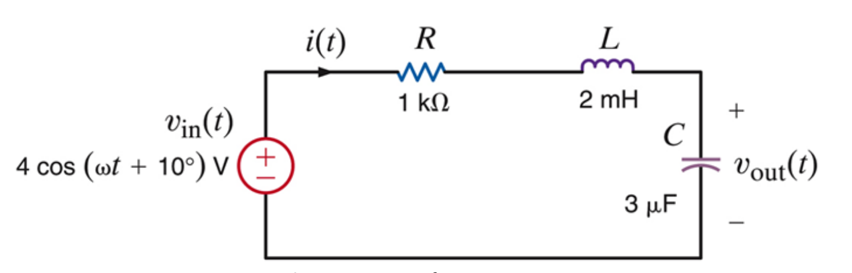

(1)

Circuit 1 for exercise 1

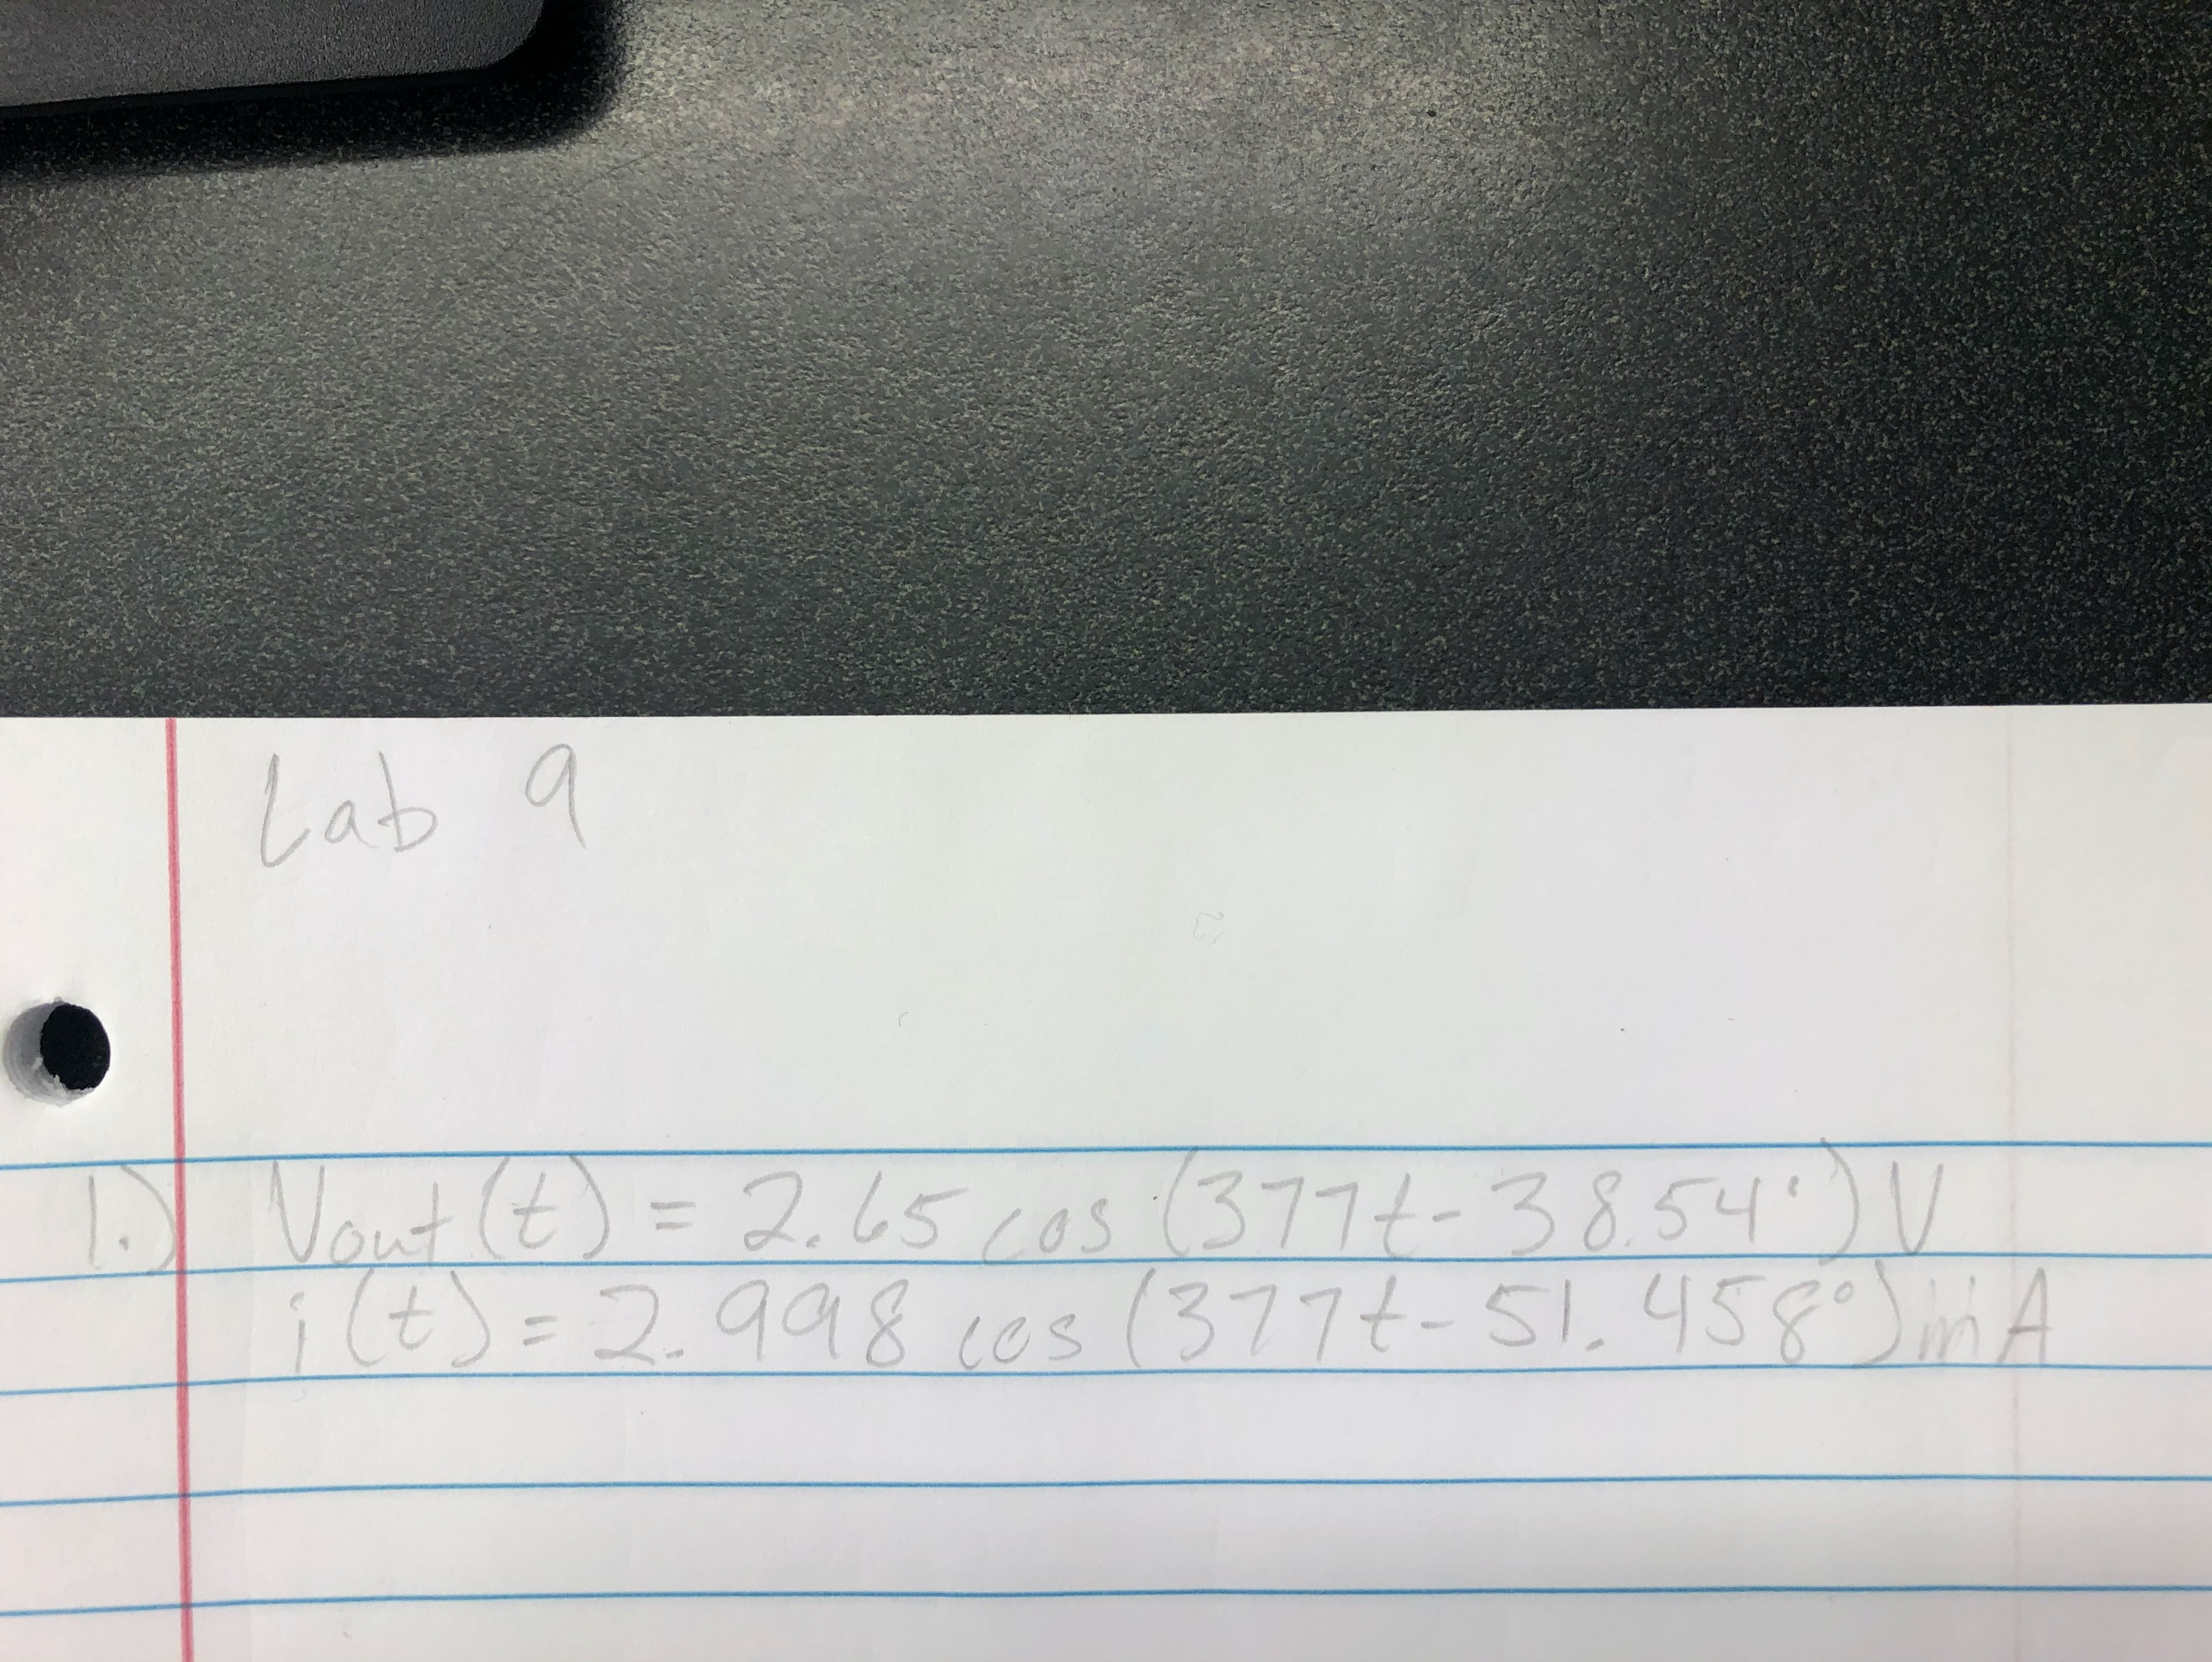

(2)

Hand-written equations

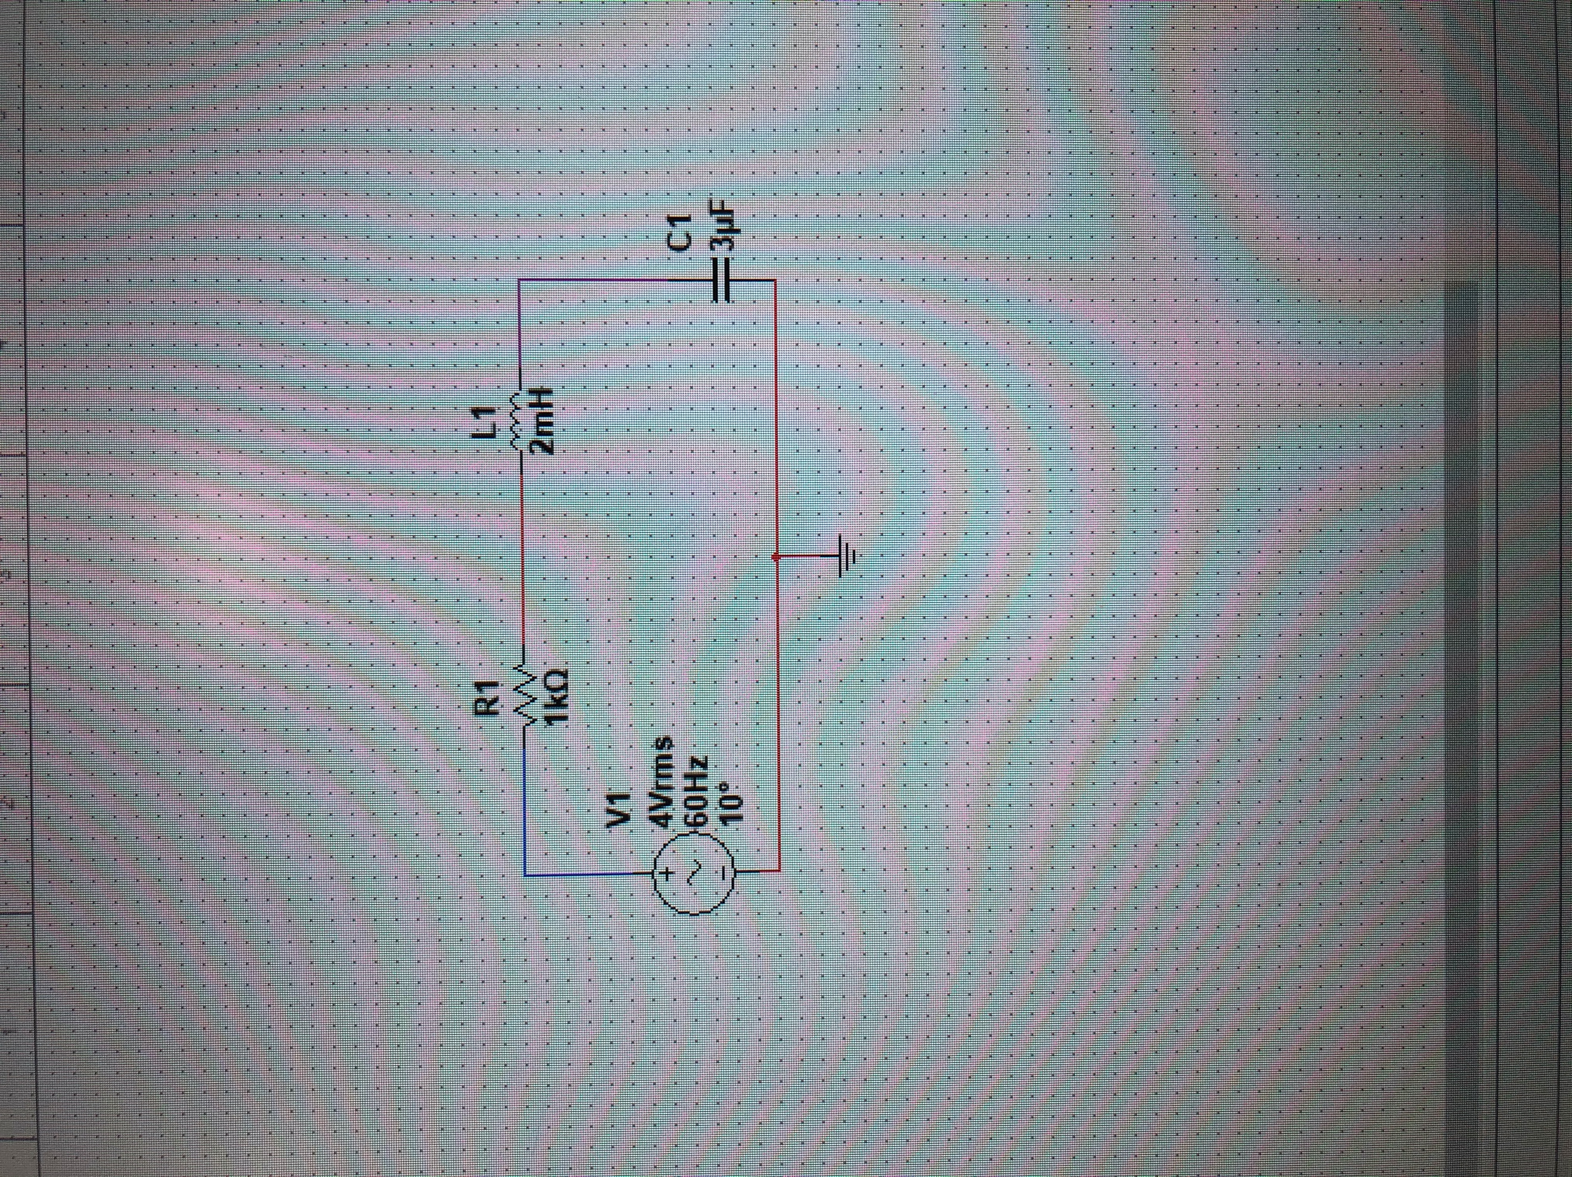

(3)

Circuit in MultiSim

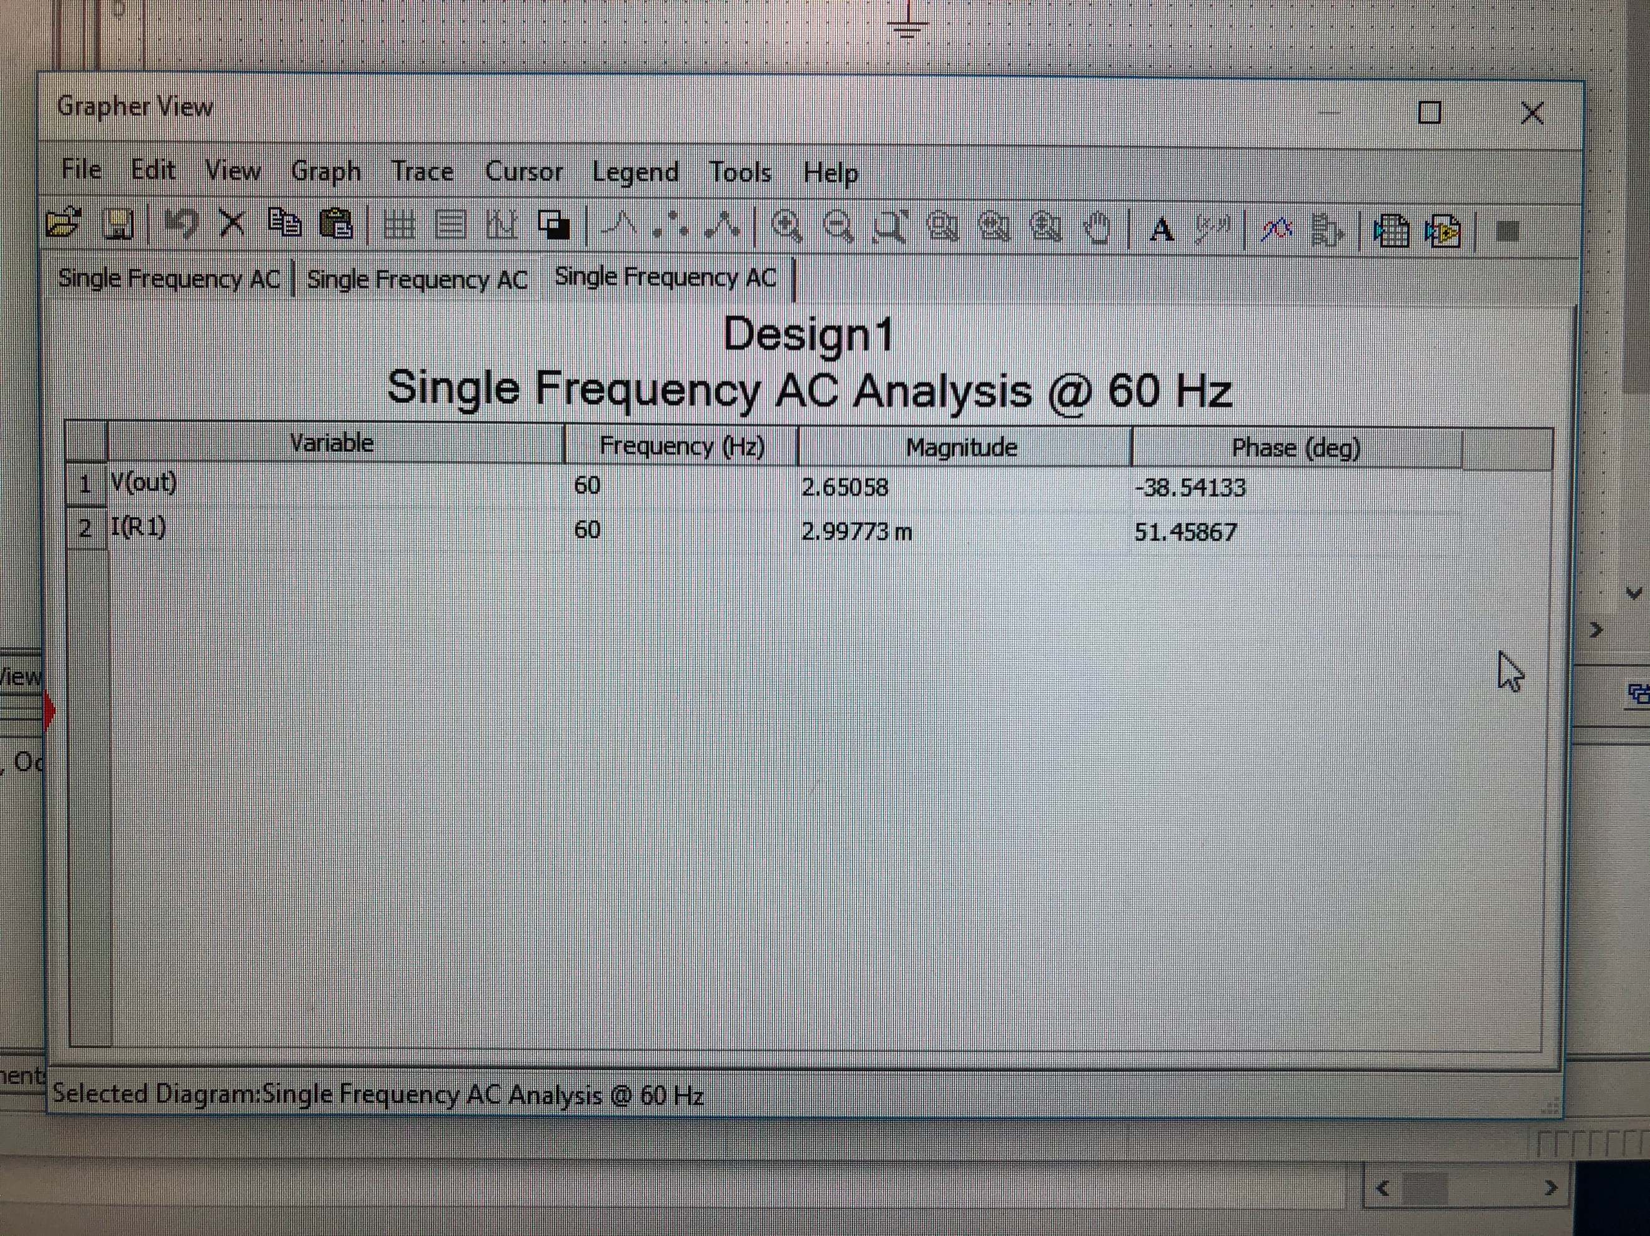

(4)

AC Sweep

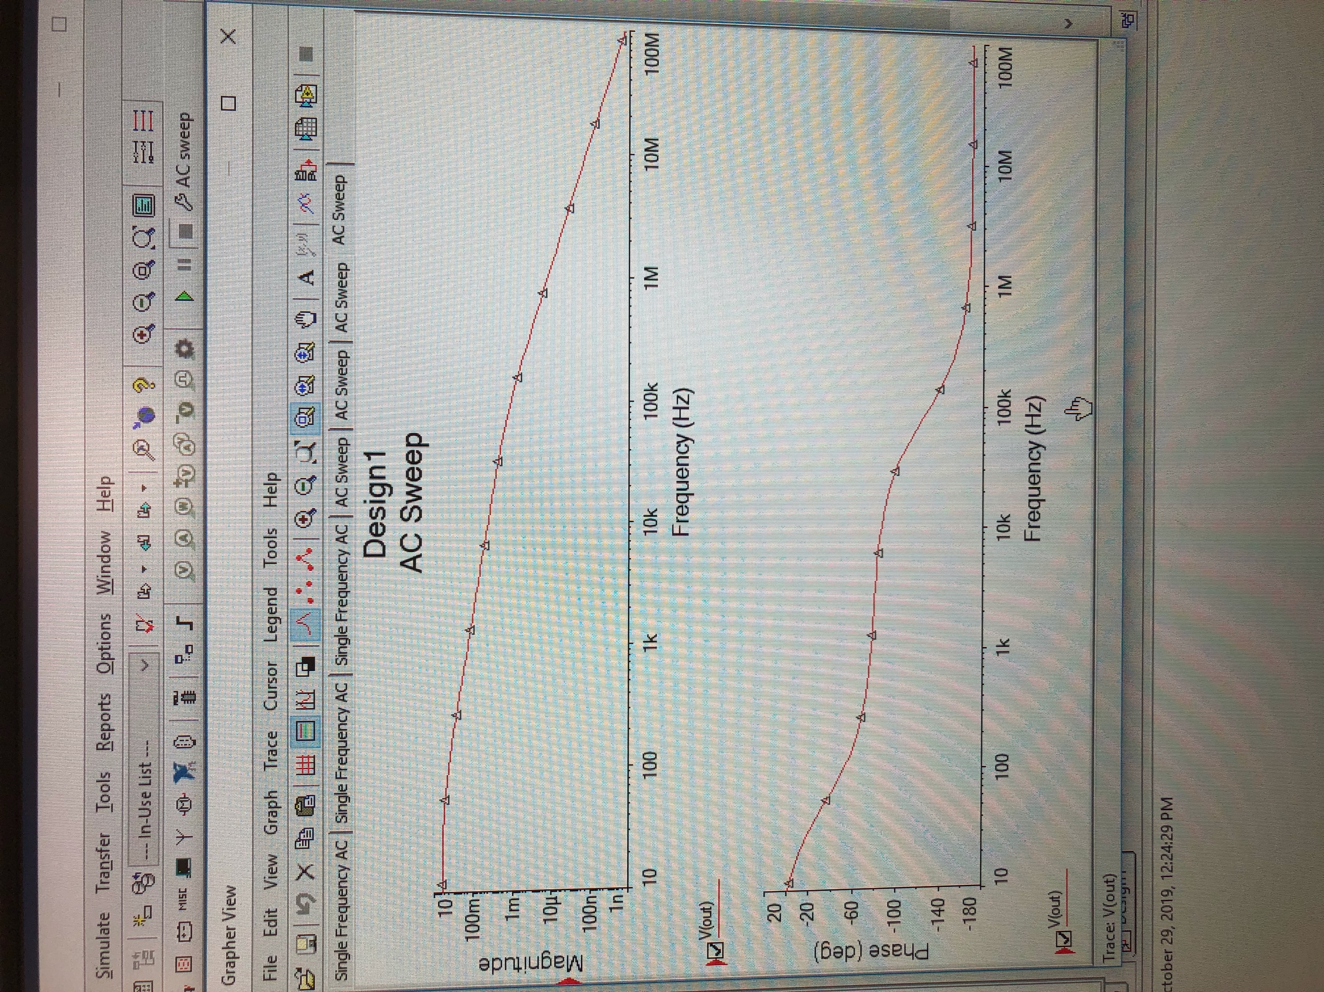

(5)

Magnitude and phase plot

Summary Table

|  |  |  |  |
| --- | --- | --- | --- |
| **Variable** | **Frequency (Hz)** | **Magnitude** | **Phase (degrees)** |
| V(t)out | 60 | 2.651 | -38.54 |
| I(t)in | 60 | 2.998 | 51.46 |

Exercise 2

Calculate V(t) for circuit 2. Simulate in MultiSim and perform AC Sweep and plot magnitude and phase.

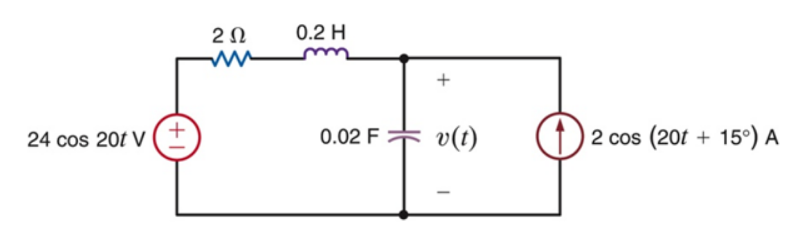

(6)

Circuit 2 for exercise 2

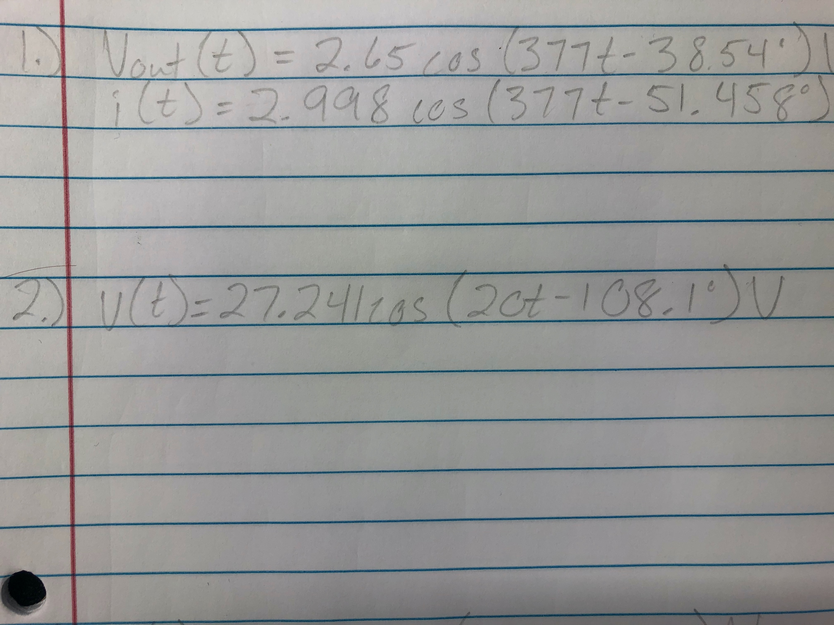

(7)

Final for exercise 2

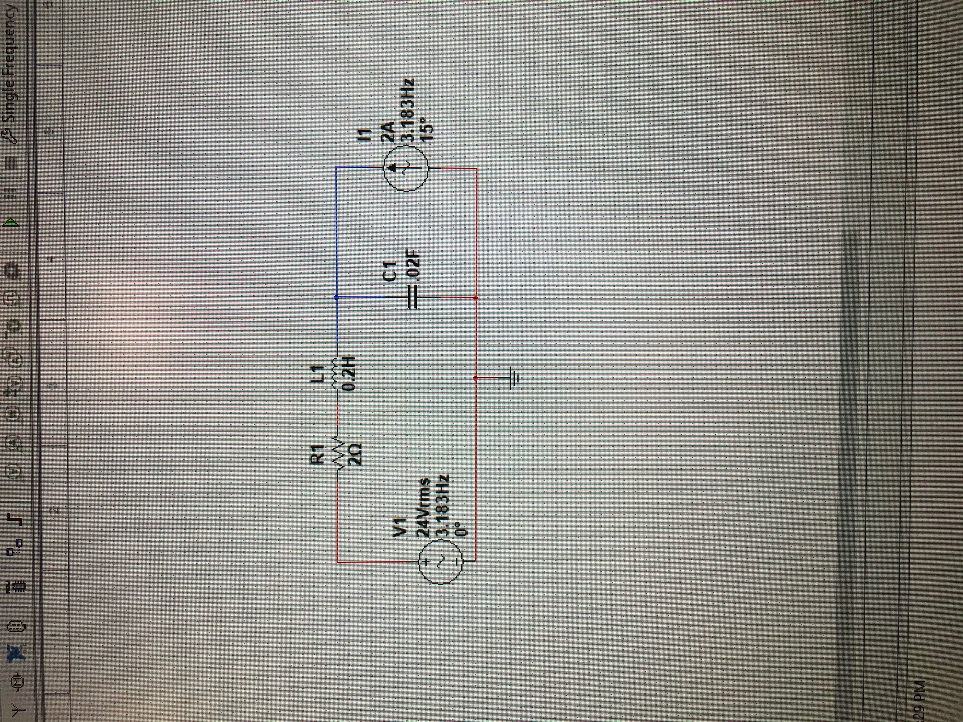

(8)

Circuit in MultiSim

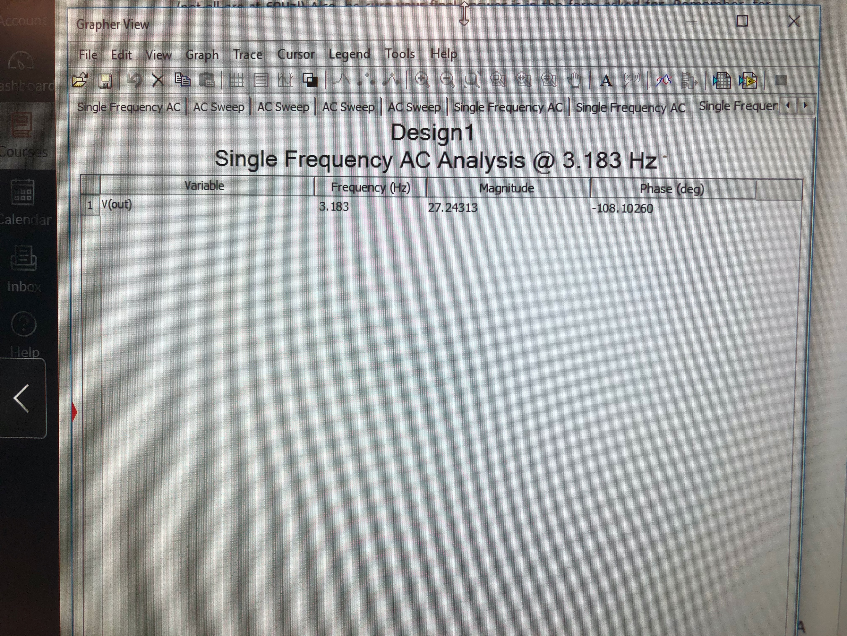

(9)

AC Sweep

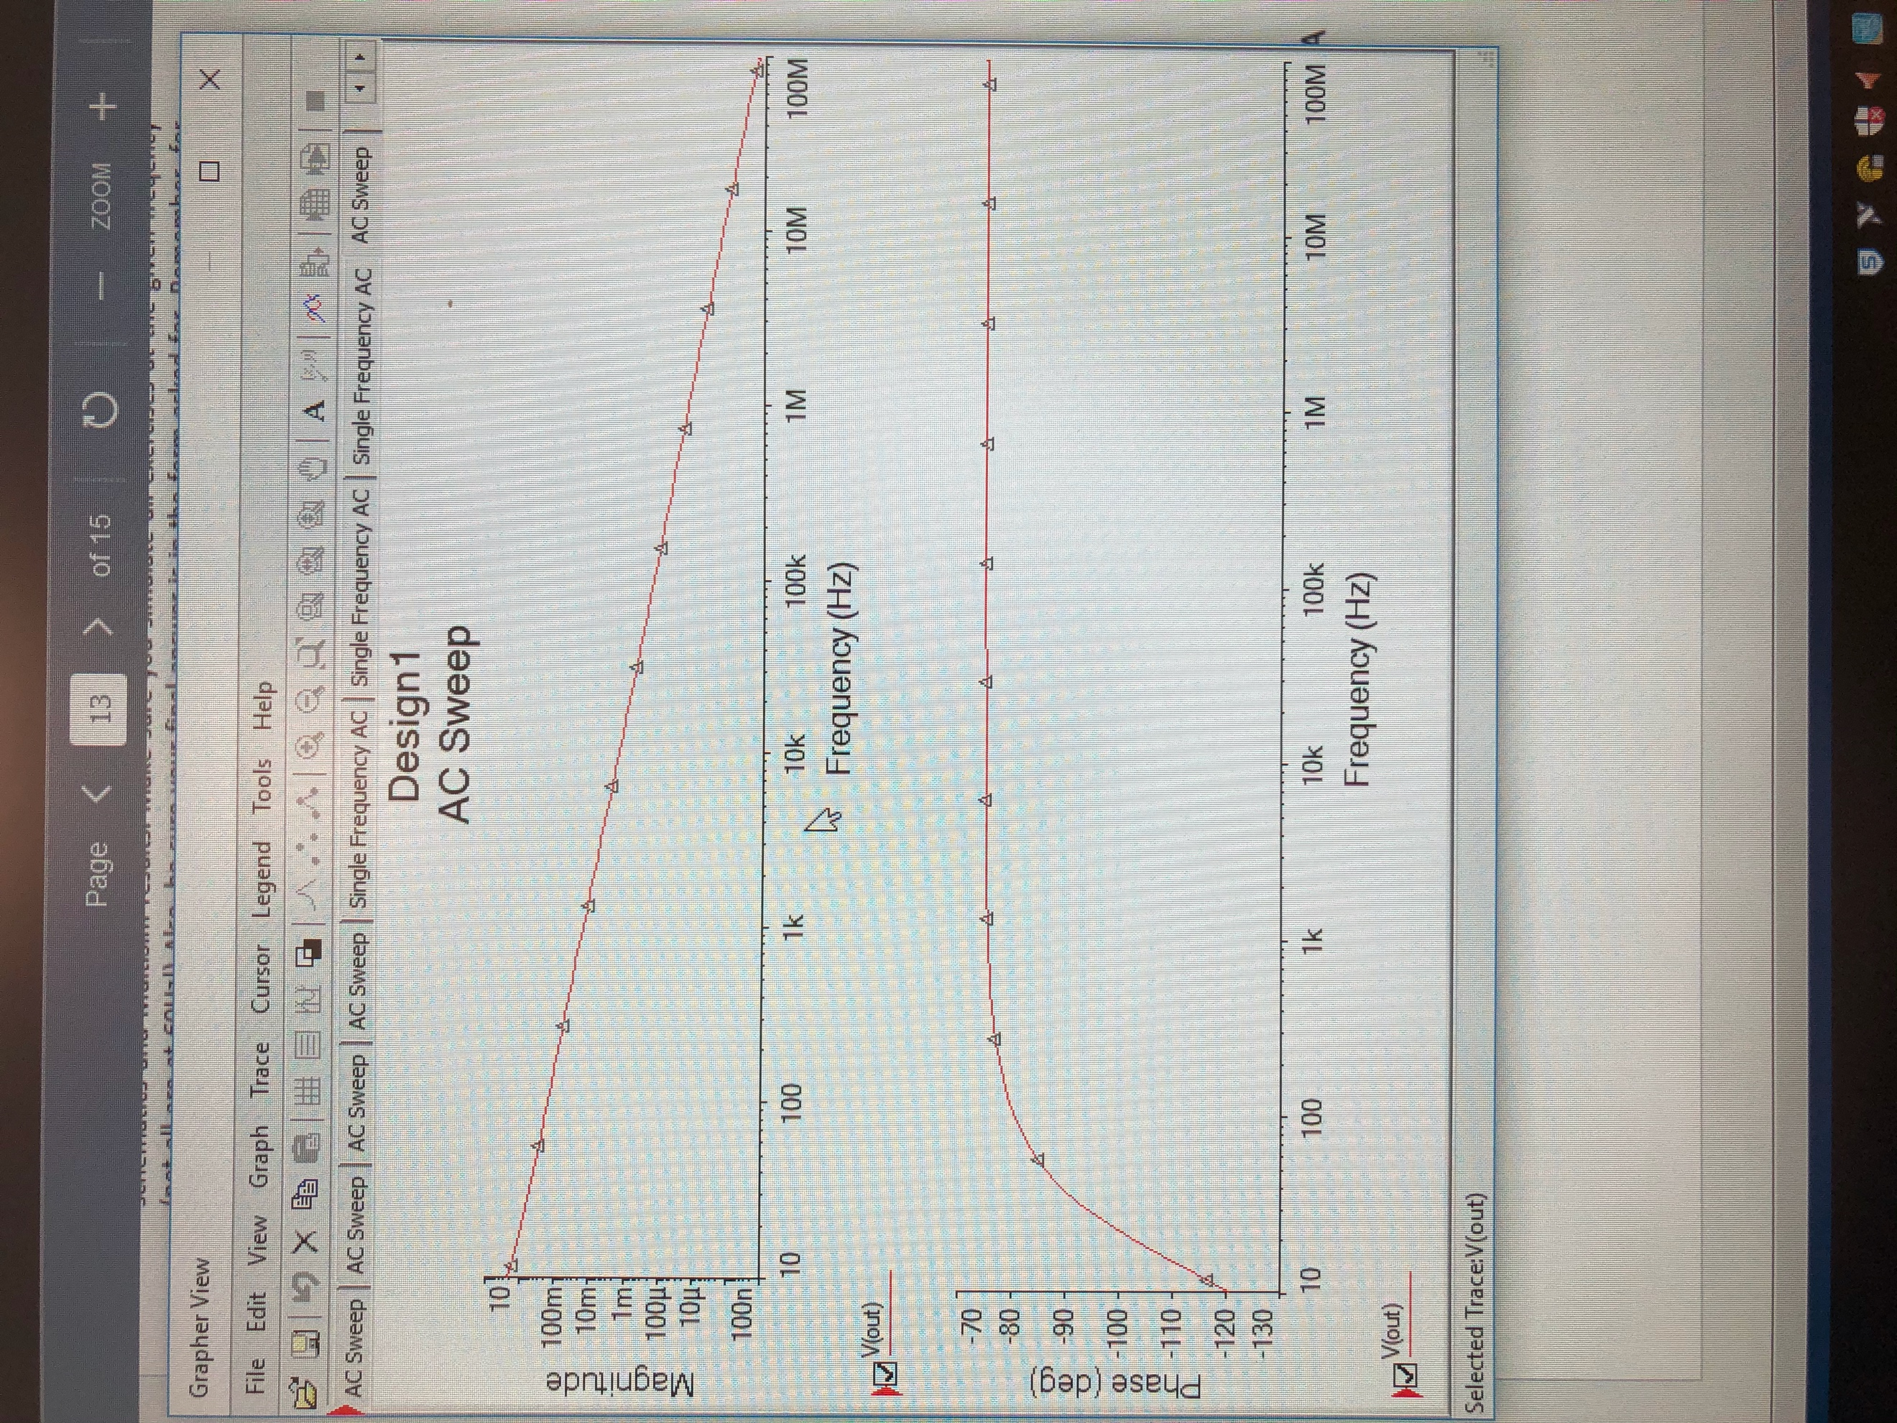

(10)

Magnitude and phase plot

Summary Table

|  |  |  |  |
| --- | --- | --- | --- |
| **Variable** | **Frequency (Hz)** | **Magnitude** | **Phase (degrees)** |
| V(t) | 3.183 | 27.241 | -108.103 |

Exercise 3

Calculate V(t) for circuit 3. Simulate in MultiSim and perform AC Sweep and plot magnitude and phase.

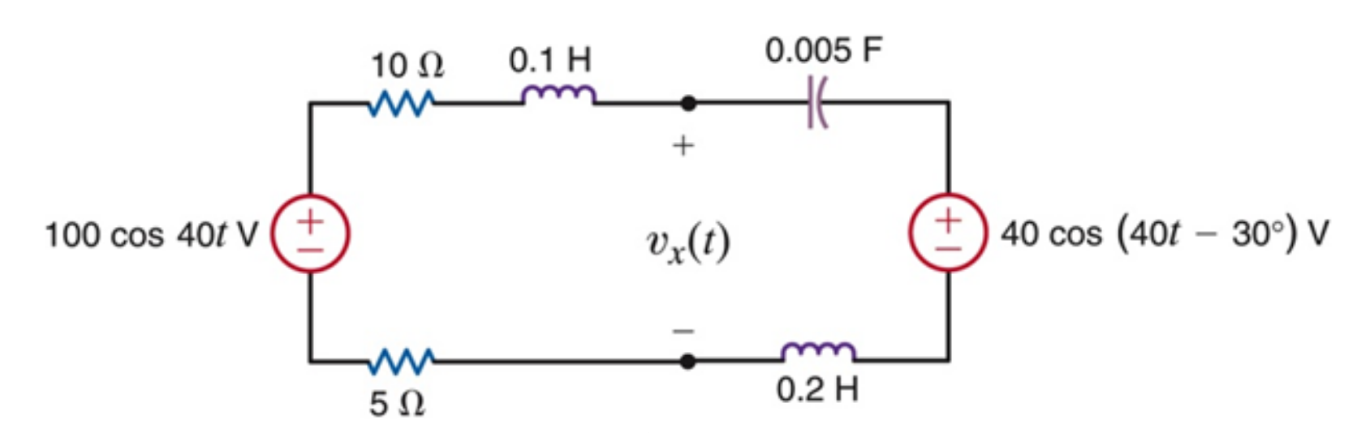

(11)

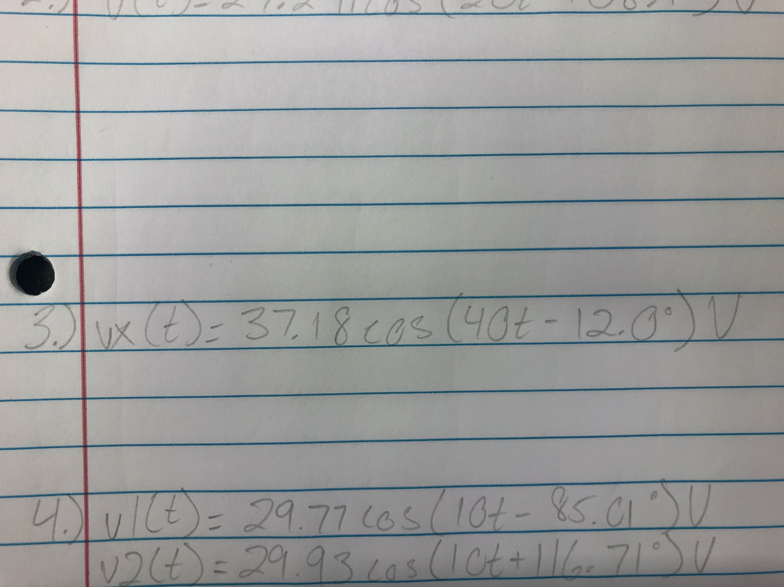

(12)

Final for exercise 3

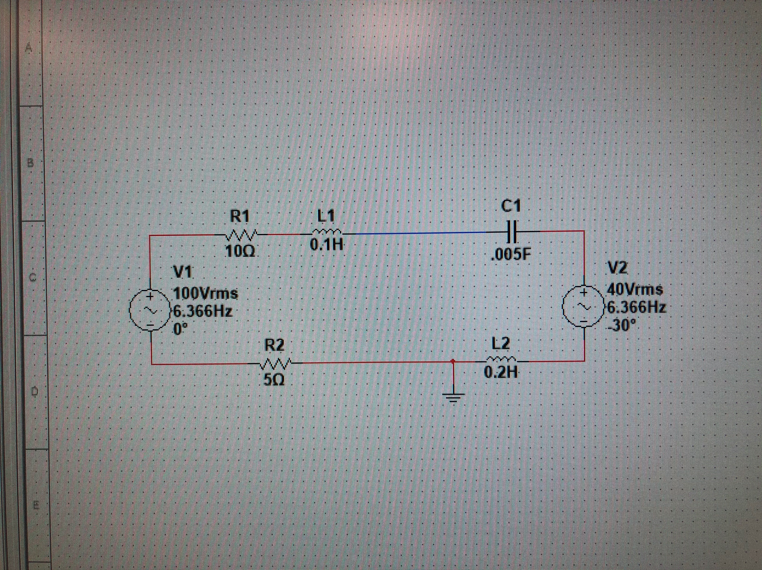

(13)

MultiSim for exercise 3

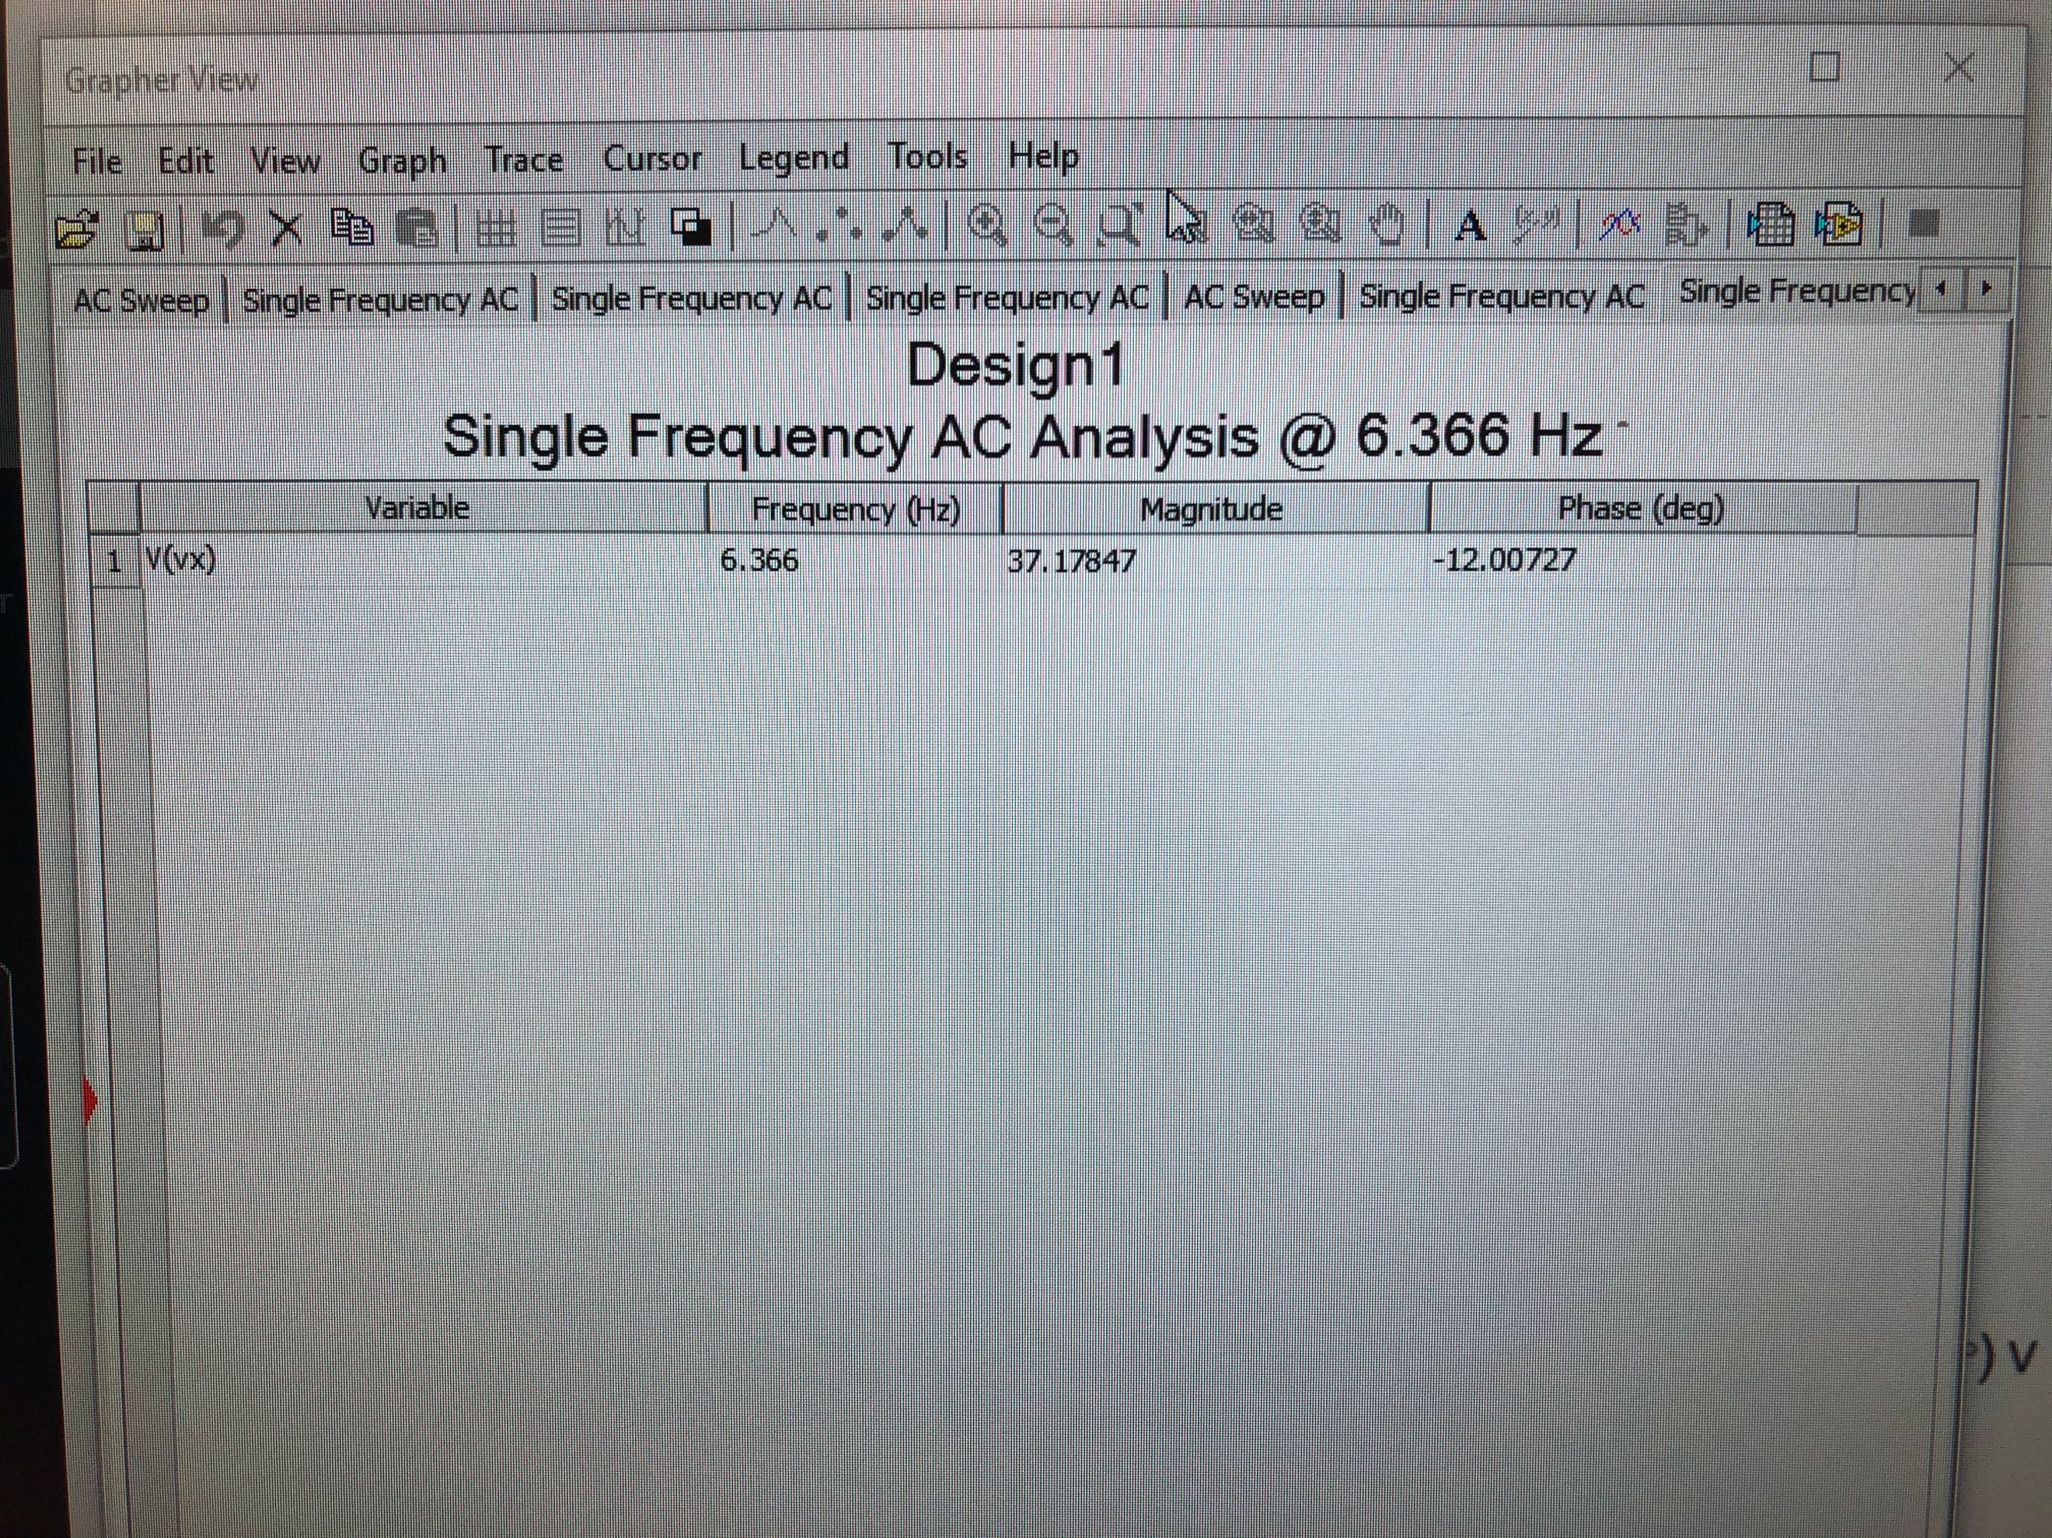

(14)

AC Sweep for exercise 3

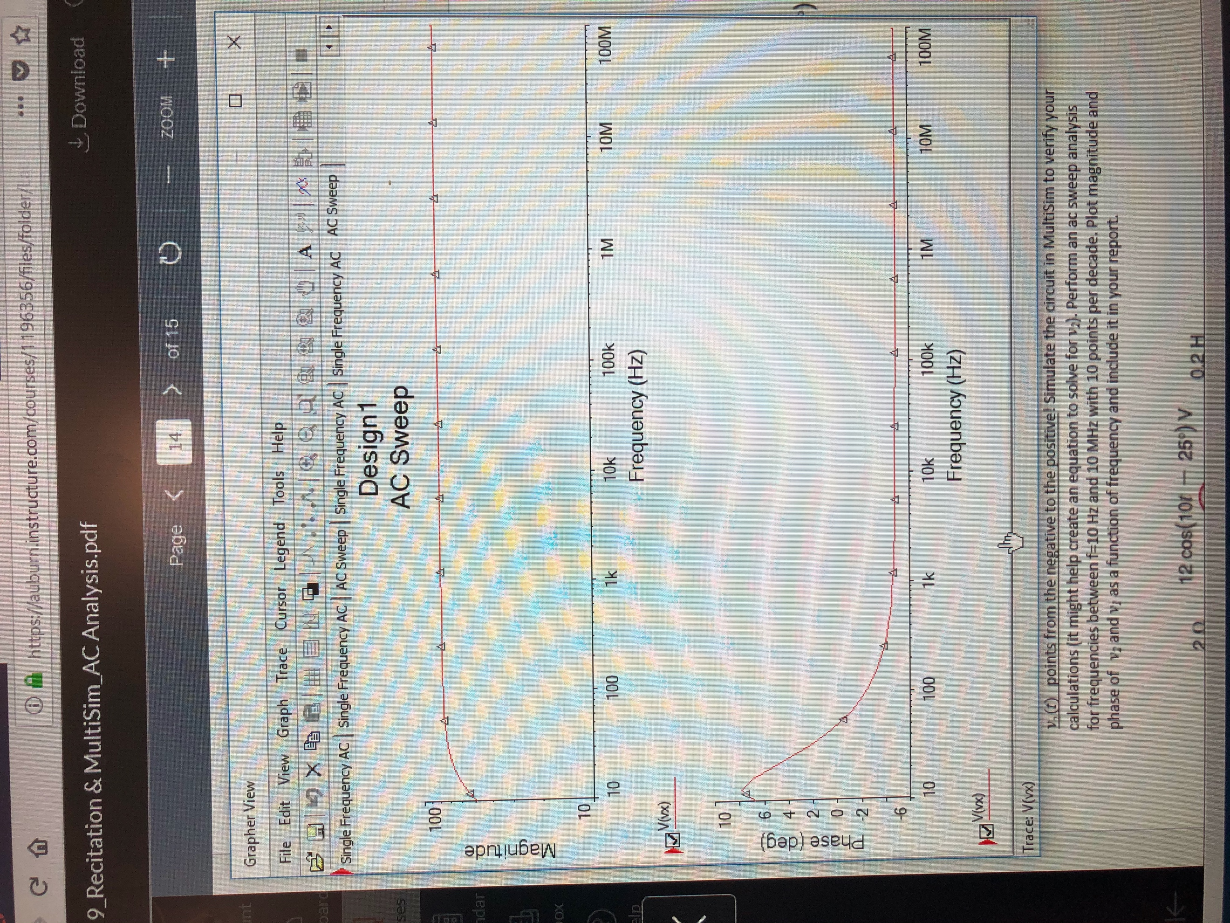

(15)

Magnitude and phase plot

Summary Table

|  |  |  |  |
| --- | --- | --- | --- |
| **Variable** | **Frequency (Hz)** | **Magnitude** | **Phase (degrees)** |
| V(t) | 6.366 | 37.18 | -12.01 |

Exercise 4

Calculate V(t)1 and V(t)2 for circuit 4. Simulate in MultiSim and perform AC Sweep and plot magnitude and phase.

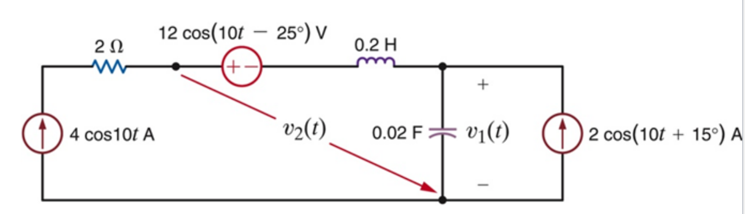

(16)

Circuit 4 for exercise 4

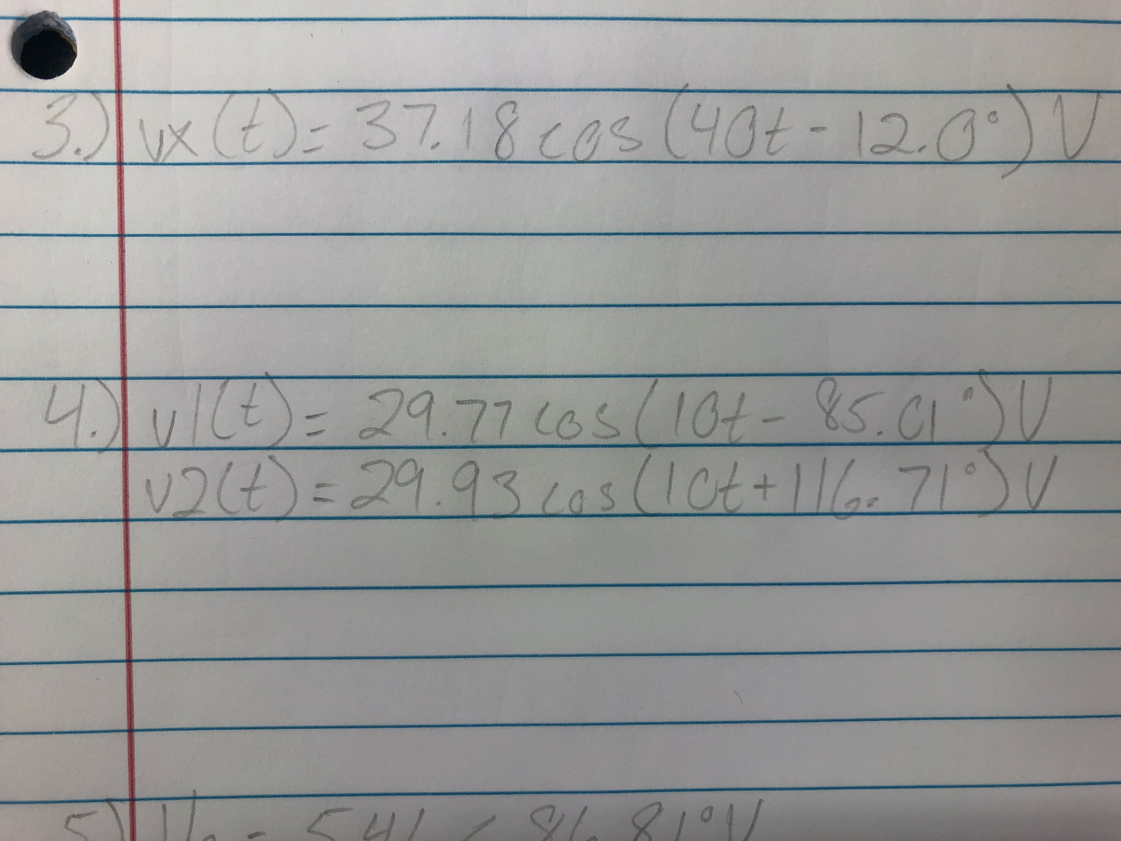

(17)

Final for exercise 4

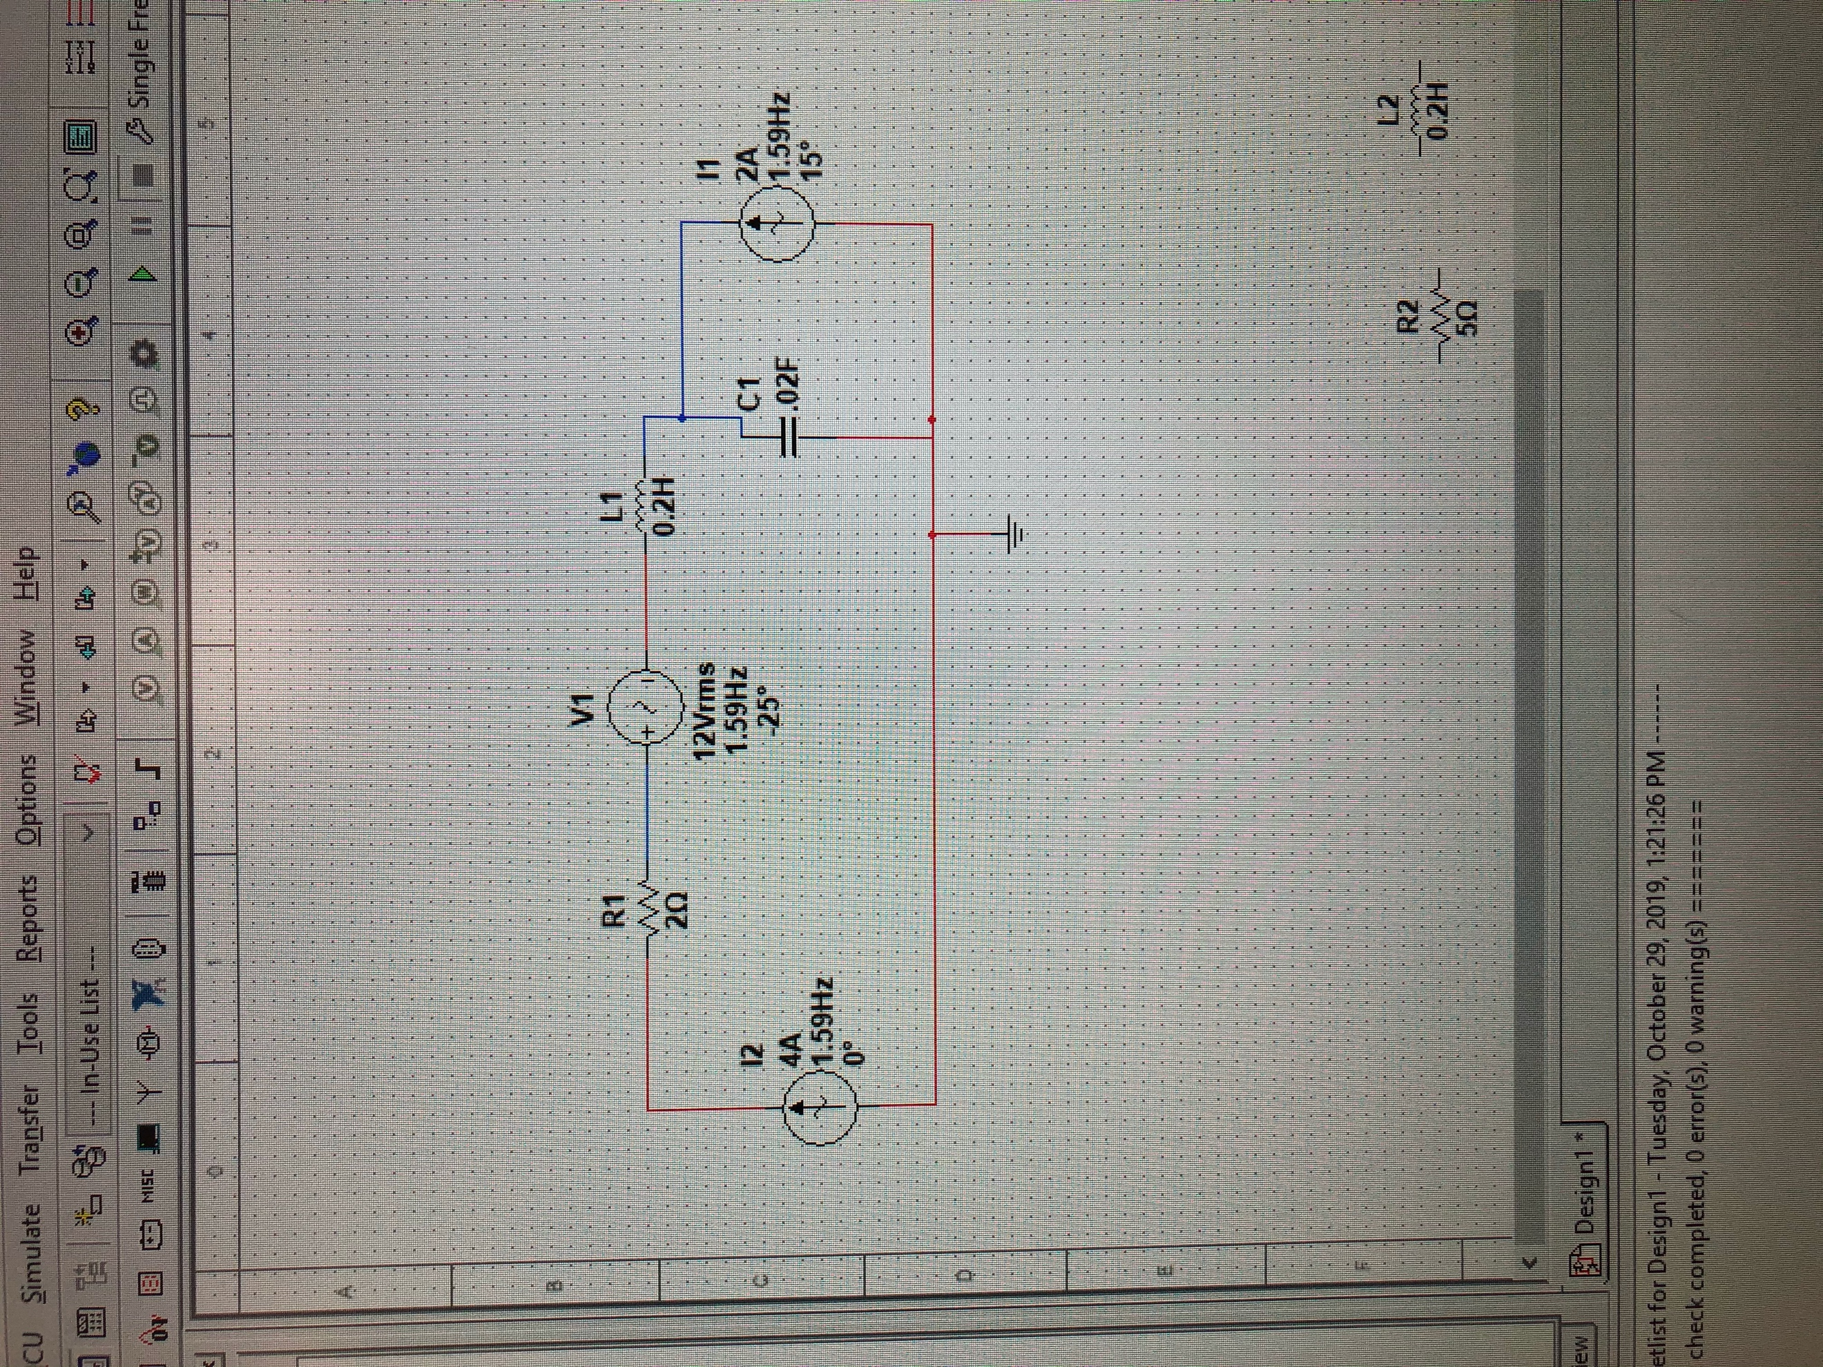

(18)

MultiSim circuit for exercise 4

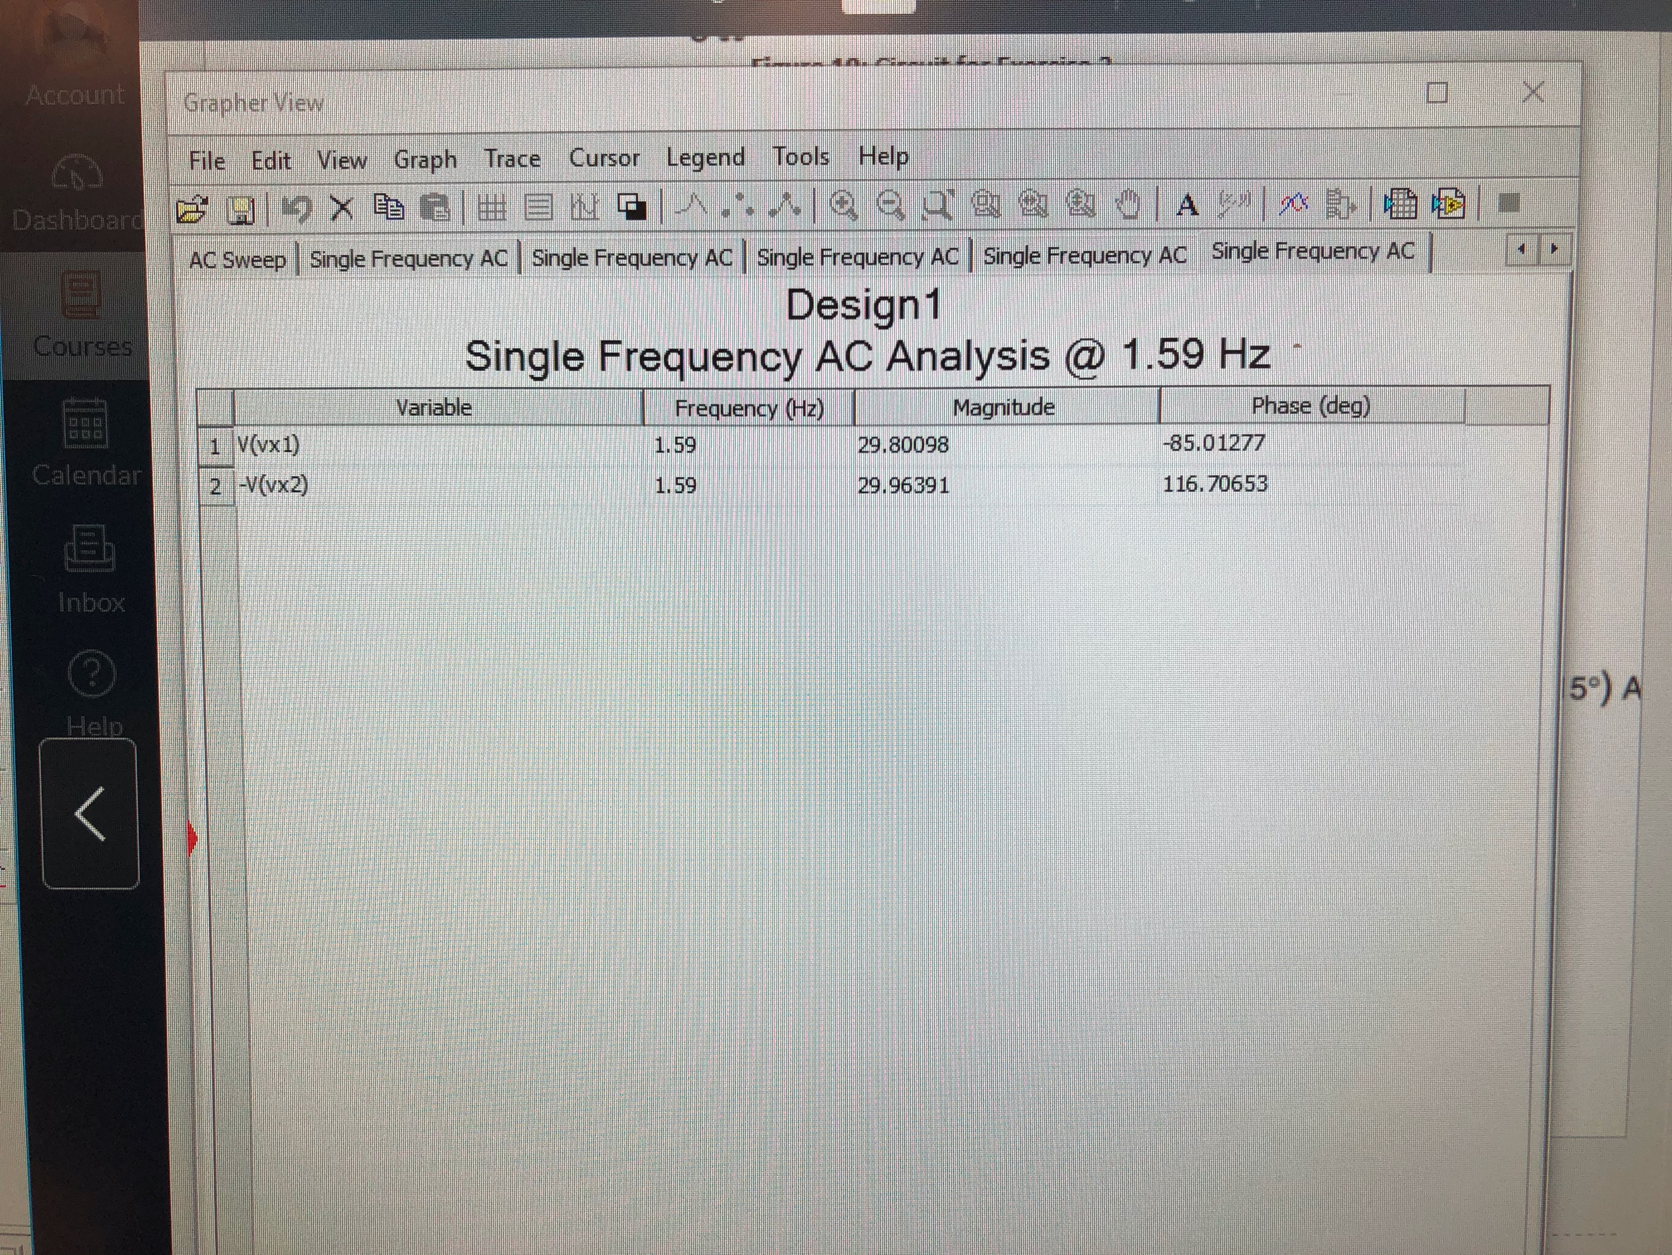

(19)

AC Sweep

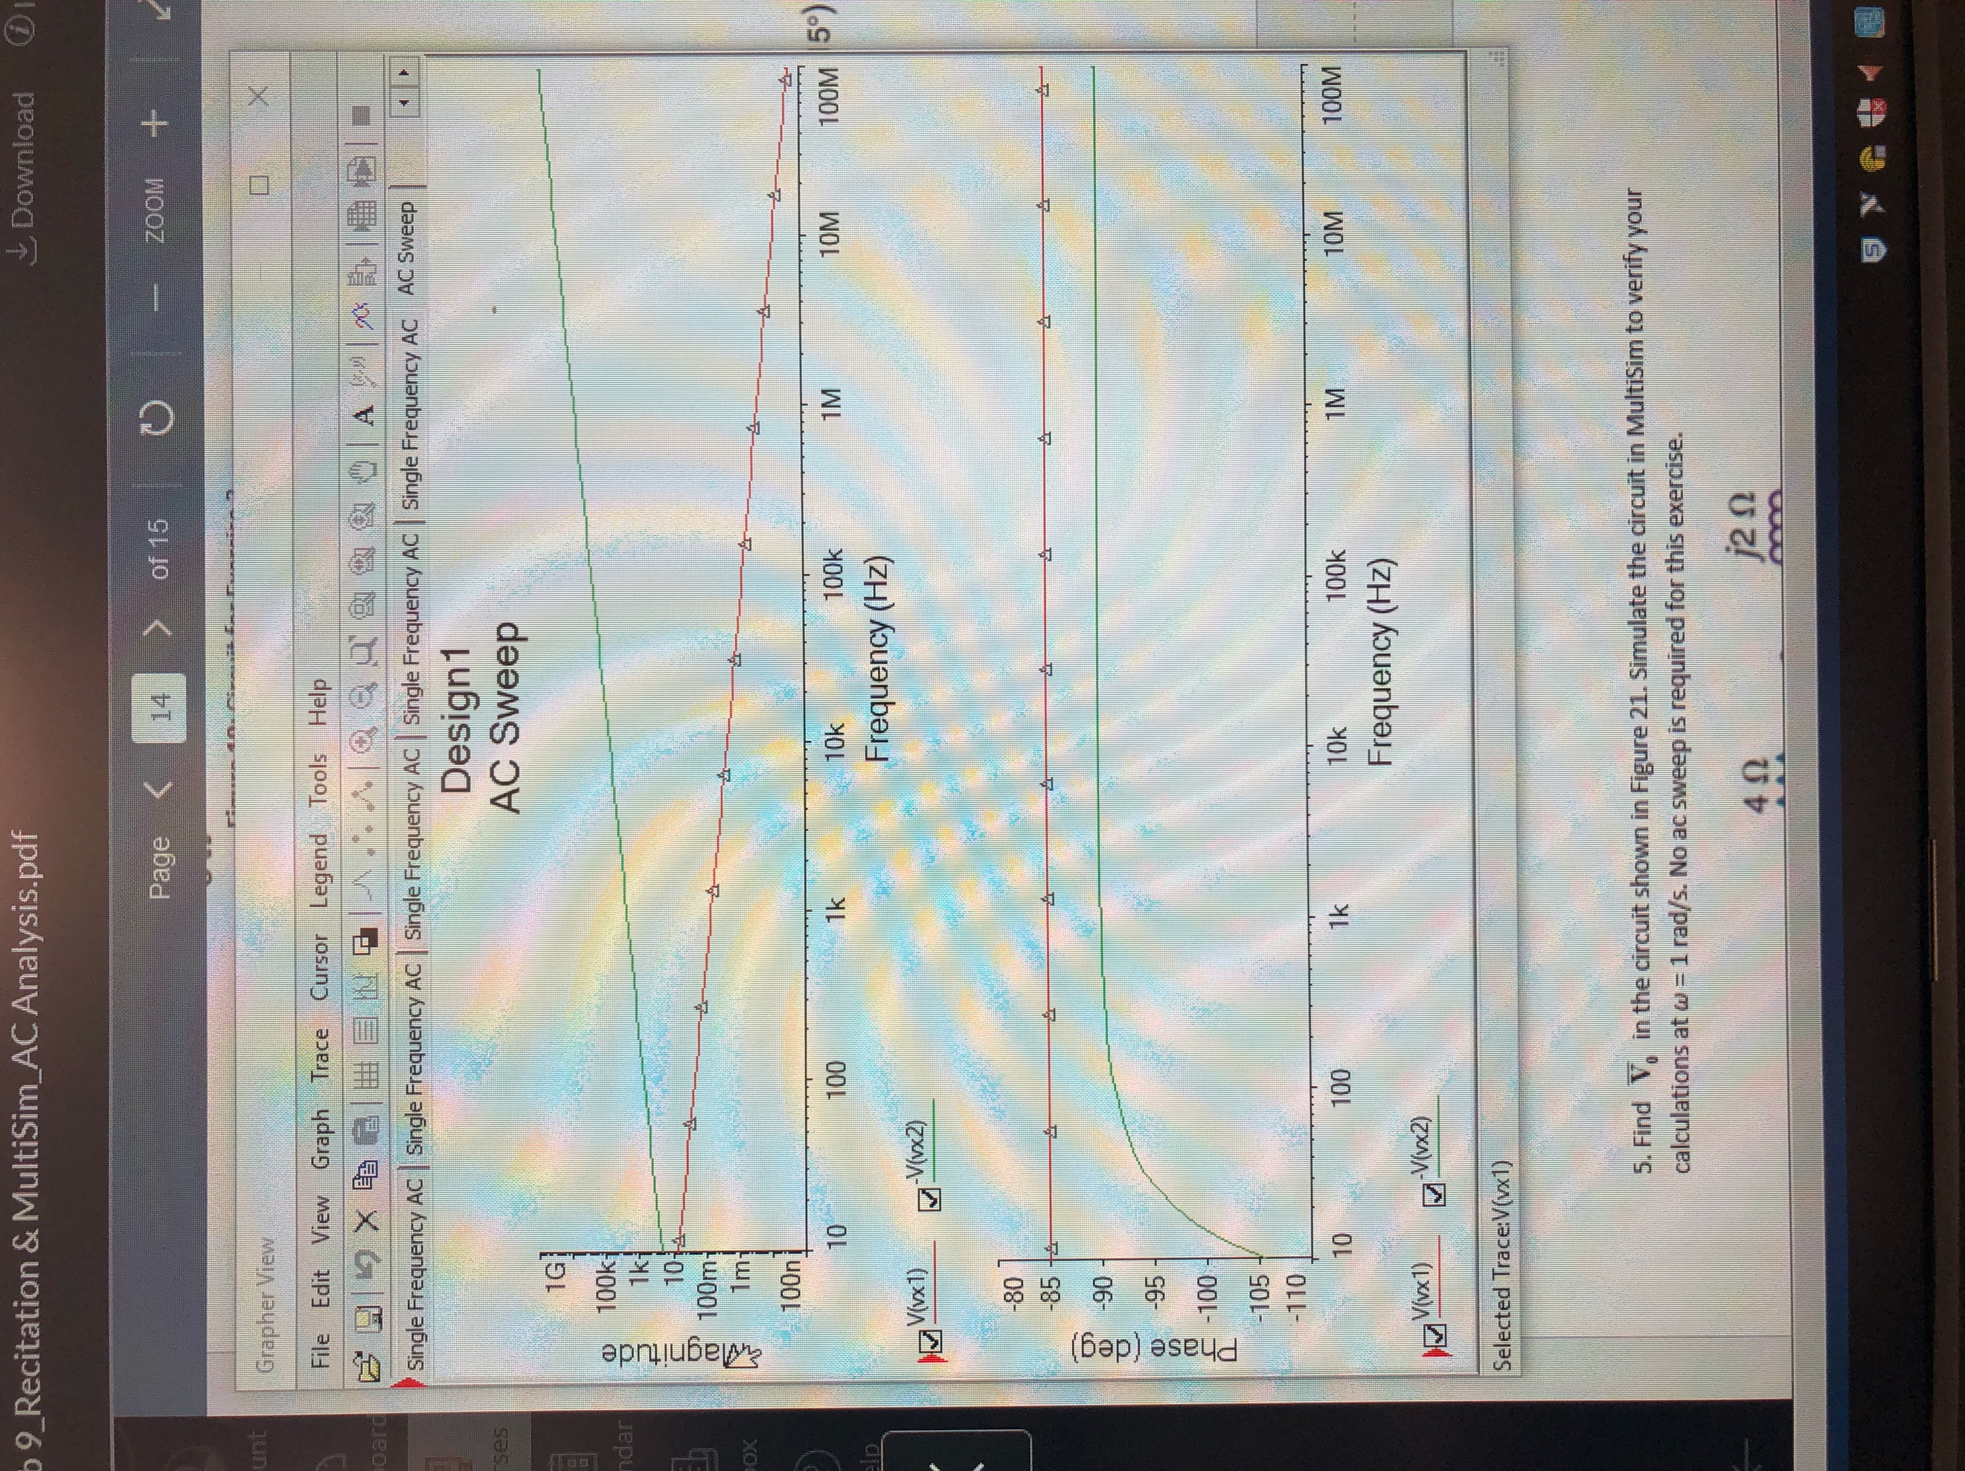

(20)

Magnitude and phase plot

Summary Table

|  |  |  |  |
| --- | --- | --- | --- |
| **Variable** | **Frequency (Hz)** | **Magnitude** | **Phase (degrees)** |
| V(t)1 | 1.59 | 29.801 | -85.013 |
| V(t)2 | 1.59 | 29.964 | 116.707 |

Exercise 5

Calculate V(0) for circuit 5. Simulate in MultiSim and perform AC Sweep.

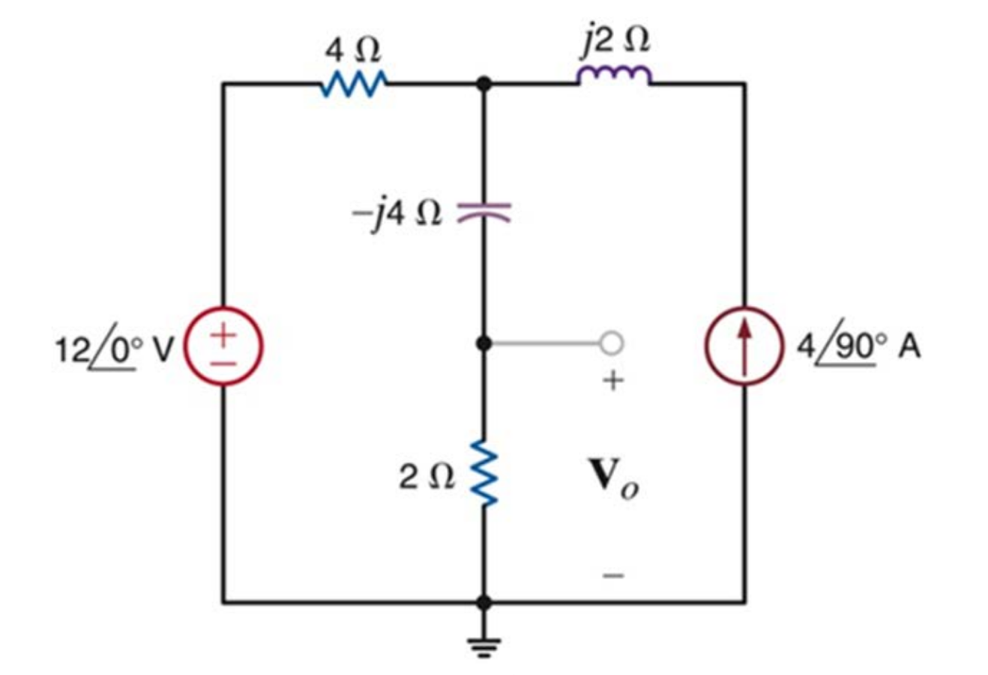

(21)

Circuit 5 for exercise 5

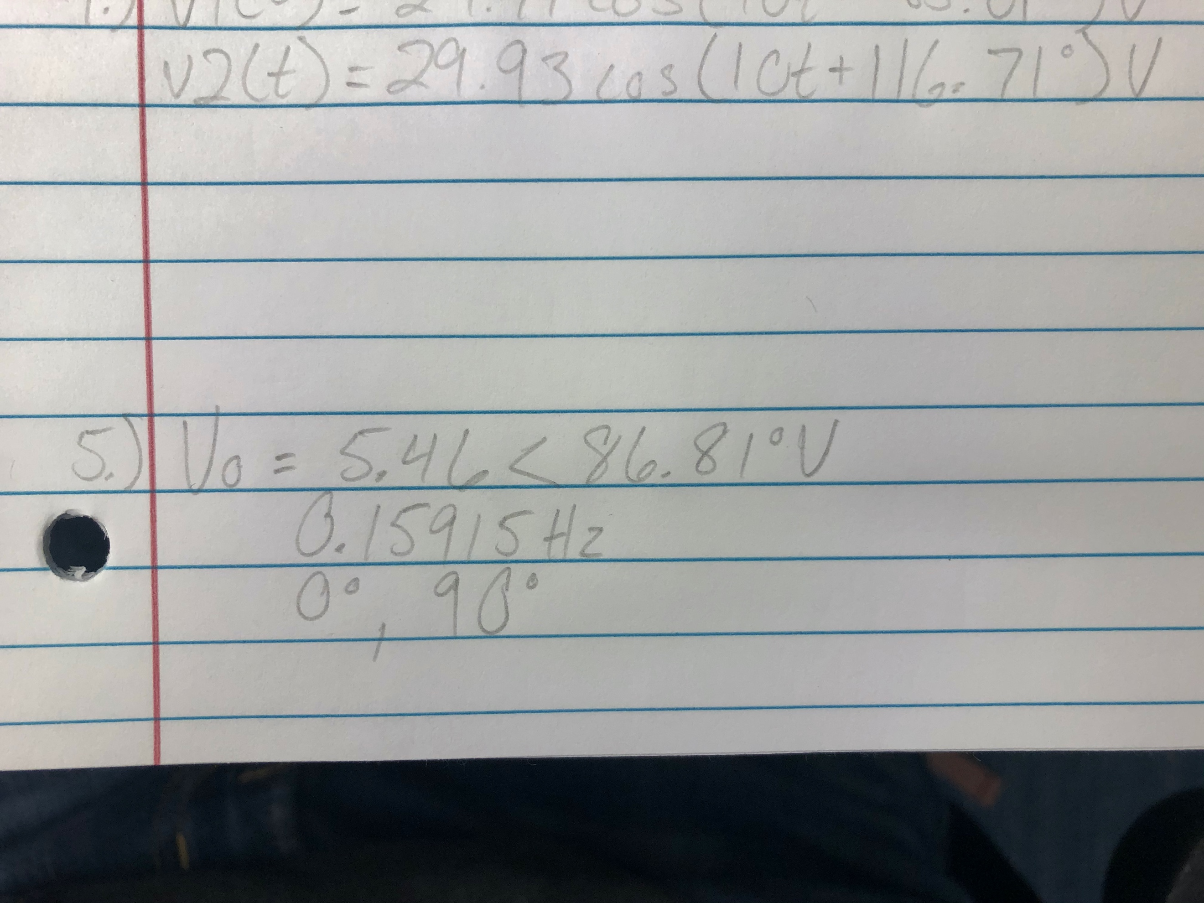

(22)

Final equation for exercise 5

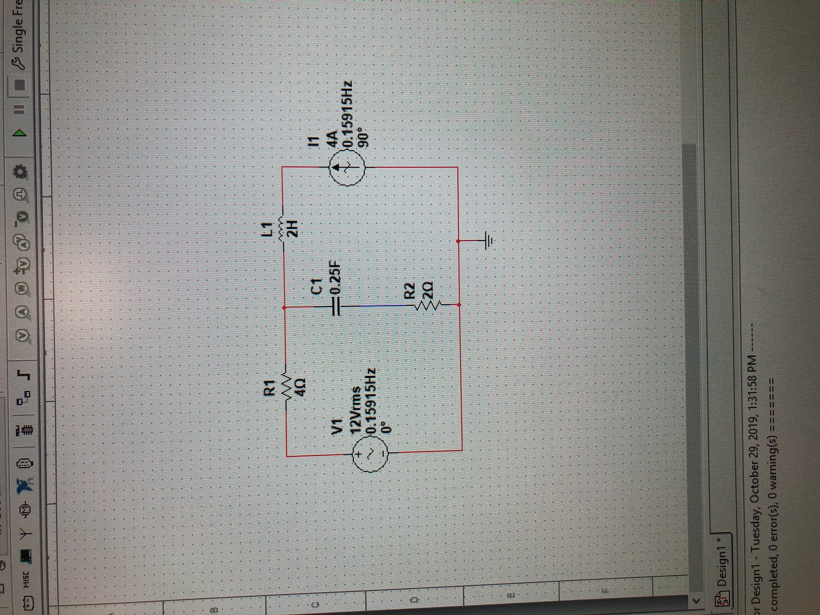

(23)

MultiSim circuit exercise 5

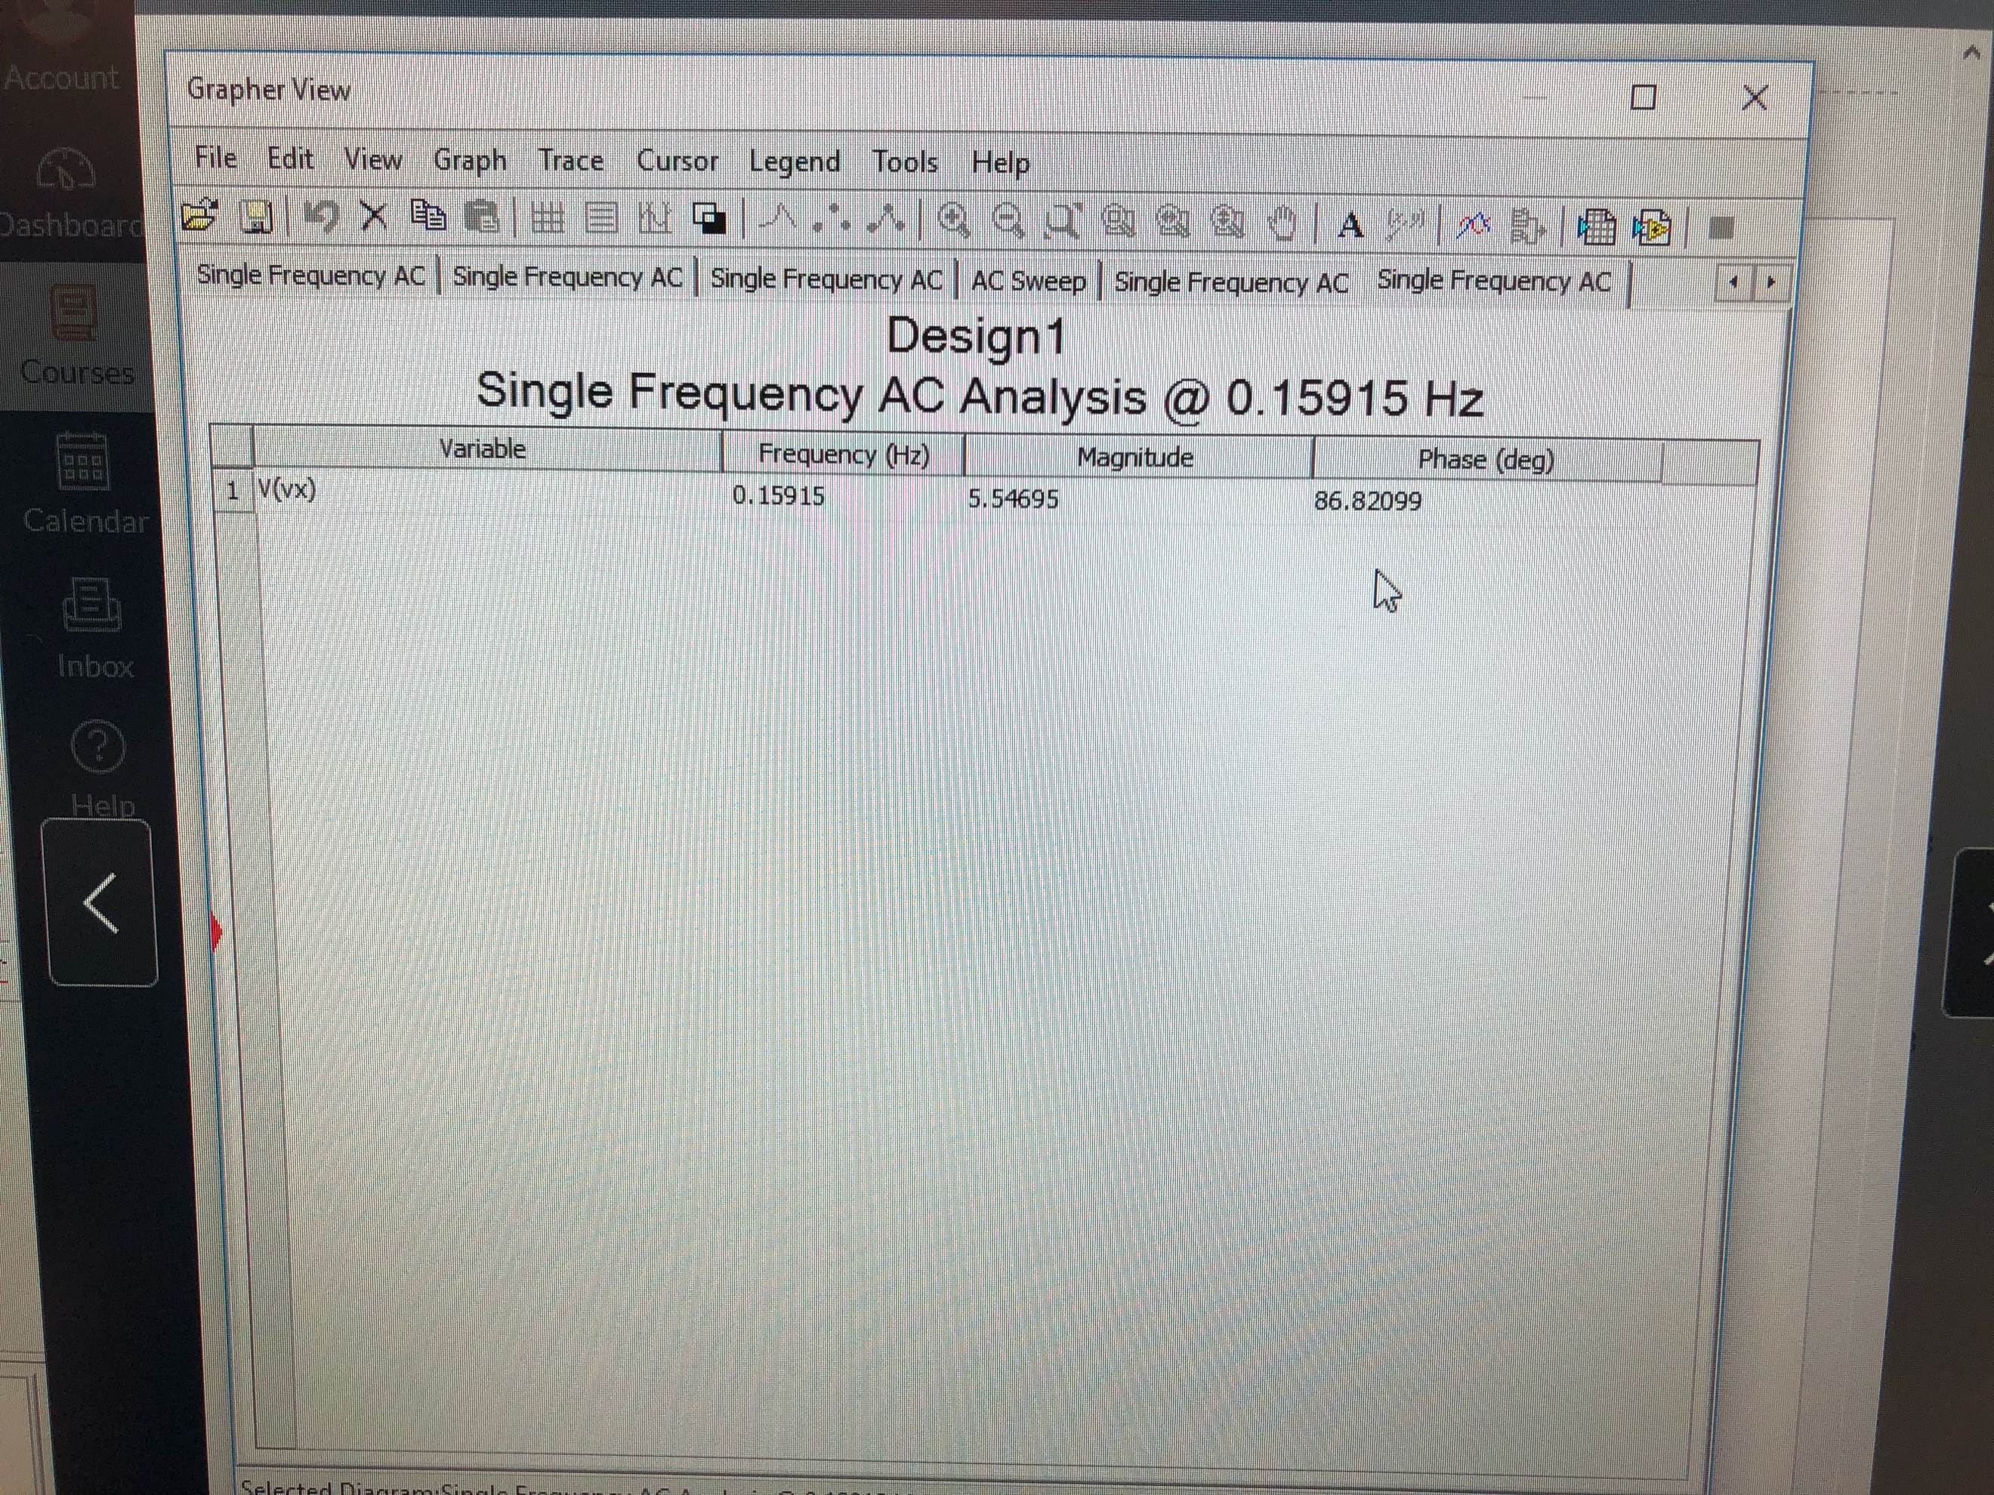

(24)

AC Sweep

Summary Table

|  |  |  |  |
| --- | --- | --- | --- |
| **Variable** | **Frequency (Hz)** | **Magnitude** | **Phase (degrees)** |
| V(t) | 0.15915 | 5.547 | 86.821 |

Conclusion

Lab 9 was based on switching everything learned previously in this course to AC circuits. AC Circuits are very important since that is the main energy source used in the United States and is used every day. This will become a very important step in becoming an electrical engineer.

Bibliography

1. Circuit 1 for exercise 1
2. Equation for exercise 1
3. MultiSim of circuit exercise 1
4. AC Sweep exercise 1
5. Magnitude and Phase plot exercise 1
6. Circuit 2 for exercise 2
7. Equation for exercise 2
8. MultiSim of circuit exercise 2
9. AC Sweep exercise 2
10. Magnitude and Phase plot exercise 2
11. Circuit 3 for exercise 3
12. Equation for exercise 3
13. MultiSim of circuit exercise 3
14. AC Sweep exercise 3
15. Magnitude and Phase plot exercise 3
16. Circuit 4 for exercise 4
17. Equation for exercise 4
18. MultiSim of circuit exercise 4
19. AC Sweep exercise 4
20. Magnitude and Phase plot exercise 4
21. Circuit 5 for exercise 5
22. Equation for exercise 5
23. MultiSim of circuit exercise 5
24. AC Sweep exercise 5